
Welcome to Cub Scouts!
This is a parent-friendly guide to help us get started together. This guide is a way to get organized and figure out some important decisions together.
Our motto is Do Your Best – perfection is not the goal.
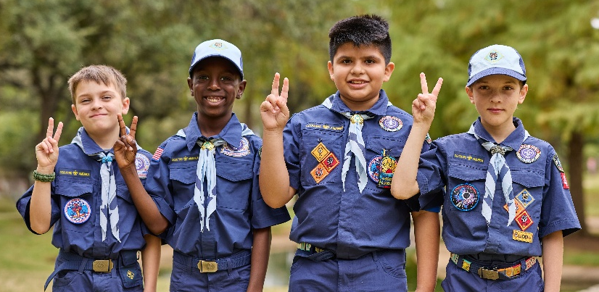
How our Pack is Organized
Pack Meetings are when everyone comes together (all families, all ages). This meeting is typically lead by the Cubmaster, with help from parents and Den Leaders.
- How often should we meet as a Pack? __________________________________________
- What day works best? _________________________________________________________
- What time works best? ________________________________________________________
- Where do we meet? ___________________________________________________________
Den Meetings are smaller groups of kids in the same grade, working on Adventures throughout the year. This meeting is typically lead by Den Leaders.
- How often do Dens meet? _____________________________________________________
- Where do Den meetings happen? ______________________________________________
- Den Leader(s)? _______________________________________________________________
______________________________________________________________________________
Committee Meetings are typically once a month for just the parents who help keep the Pack running smoothly. We check in on the calendar, upcoming events, supplies, and logistics so meetings are prepared and fun for the kids. This is about staying organized and supporting our leaders.
- What day and time work best? _________________________________________________
- Location / format? ____________________________________________________________
- Who plans or facilitates: _______________________________________________________
Sharing the Work: Pack Leadership
Required Roles:
- Cubmaster: helps lead Pack meetings, supports Den Leaders, and keeps things fun
- Committee Chair: helps organize the adults and logistics
- Den Leaders: work directly with your child and other kids in their grade level (Den)
Helpful Support Roles:
- Treasurer: tracks Pack money, pays expenses, and keeps things transparent
- Advancement Coordinator: helps make sure adventures, badges, and awards get recorded and handed out
- Communications Lead: sends reminders, updates, and calendar info to families
- Outdoor Coordinator: helps find locations or ideas for outings and field trips
- Committee members: parents who keep the Pack running smoothly
Cubmaster
Committee Chair
Den Leader – Lions (K)
Den Leader – Tigers (1st)
Den Leader – Wolves (2nd)
Den Leader – Bears (3rd)
Den Leader – Webelos (4th)
Den Leader – Arrow of Light (5th)

Notes: _____________________________________________________________________________
____________________________________________________________________________________
____________________________________________________________________________________
How We Communicate
Clear communication helps our Pack run smoothly and keeps everyone on the same page. We’ll choose one primary way to share information, so families know where to look.
Our primary communication method:
- Email (Pack email?)
- Messaging app (GroupMe, WhatsApp, Band, etc.)
- Facebook page
- ScoutBook+
- Other: _______________________________________
What we’ll use it for: meeting reminders and schedule updates, event details and sign-ups, important Pack announcements.
- Who sends Pack-wide updates? ________________________________________________
- How often can families expect messages? ______________________________________
- Questions or notes: ___________________________________________________________
Costs & Basics
We’ll keep costs transparent and simple. Today’s goal is awareness, not final decisions.
Basic costs to be aware of:
- Registration fee is $85 per Scout, and $65 per adult annually
- Uniform pieces (not required immediately)
- Occasional activity costs

- Many Packs have their own dues, so they can collect money up front to pay for things that will cost money later in the year, like awards, Pinewood Derby cars, campouts, activities, etc.
How Pack expenses will be handled:
- Covered by fundraising
- Covered by dues
- Combination of both
- To be decided
If cost is a concern at any point, please let us know. We want every child and family to be able to participate in Scouting.
Pack Norms & Shared Expectations
Every Pack operates a little differently. These are general decisions that help set expectations for families and leaders.
Uniform Expectations
- Uniform expectation (required / encouraged / optional) ___________________________
______________________________________________________________________________
- When uniforms are typically worn (Pack meetings, events, etc.) ___________________
______________________________________________________________________________
Family Participation Expectations
- Do parents stay at meetings? __________________________________________________
- Are siblings welcome? ________________________________________________________
Photos & Social Media Use
- Photos shared internally / on social media / not shared: __________________________
______________________________________________________________________________
Attendance Expectations
- How our Pack approaches attendance: _________________________________________
______________________________________________________________________________
- How we handle missed meetings or activities: ___________________________________
______________________________________________________________________________
- Anything families should know about attendance: _______________________________
______________________________________________________________________________
Advancement Pace
- How our Pack approaches advancement: _______________________________________
______________________________________________________________________________
- Where advancement will typically happen (meetings, at home, both): _____________
______________________________________________________________________________
- Anything families should know about advancement expectations: _________________
______________________________________________________________________________
Notes: _____________________________________________________________________________
____________________________________________________________________________________________________________________________________________________________________________________________________________________________________________________________
Planning the Next Few Months
Dates to put on the calendar:
- First Pack meeting: ___________________________________________________________
- Regular Pack meeting schedule: _______________________________________________
- Den meetings begin: __________________________________________________________
Activities / Events (1-2 to start)
- ____________________________________________________________________________________________________________________________________________________________
- ____________________________________________________________________________________________________________________________________________________________
School breaks / conflicts to note:
____________________________________________________________________________________________________________________________________________________________________________________________________________________________________________________________

Program Planning Made Easy
Cub Scout programming is already written for you. Leaders don’t need to create lessons or activities from scratch – the program provides a clear roadmap. You are not expected to invent activities from scratch. We have a few tools available to help kick off these first few months.
- 3-Month Calendar & Program Guide
  - Designed to provide a plan and structure for the first three months
- Den Leader Kits
  - Paired with the 3-Month Calendar and Program Guide, it provides most of the materials needed for the first four Den meetings.
Pack Resource Binder
The Pack Resource Binder is here to support parents and leaders. It includes meeting templates, planning guides, fundraising information, key contacts, the Cub Scout Leader Book, recruitment resources, extra applications, and more. It’s designed to narrow down the thousands of resources you can find online.
Where will the binder be kept? ________________________________________________________
Online Resources and Tools
My.Scouting is the main system used by Scouting. We use it for:
- Leader registration and required training
- Keeping rosters and contact information up to date
- Accessing Safeguarding Youth Training and other adult training courses
- Tracking advancement
- Responding to new families that are interested in joining the Pack
- Accepting both adult and youth applications

- Website: my.scouting.org
The Scouting Colorado website connects us to what’s happening locally here in Colorado. We use it for:
- Large Council events and activities
- Program opportunities and calendars
- Local resources and updates
- Website: scoutingcolorado.org

What Success Looks Like This Year
For our Scouts, success looks like: ________________________________________________________________________________________________________________________________________________________________________
For our families, success looks like: ________________________________________________________________________________________________________________________________________________________________________
For our leaders, success looks like: ________________________________________________________________________________________________________________________________________________________________________
Things we want to prioritize this year: ________________________________________________________________________________________________________________________________________________________________________
Things we are okay not doing yet: ________________________________________________________________________________________________________________________________________________________________________

Notes: ____________________________________________________________________________________________________________________________________________________________________________________________________________________________________________________________________________________________________________________________________________________________________________________________________________________________________________________________________________________________________________________________________________________________________________________________________________________________________________________________________________________________________________________________________________________________________________________________________________________________________________________________________________________________________________________________________________________________________________________________________________________________________________________________________________________________________________________________________________________________________________________________________________________________________________________________________________________________________________________________________________________________________________________________________________________________________________________________________________________

