Ready, Set, Scout!

Meetings, Adventures, and Resources for Your First 3 Months
The Cub Scout Motto: “Do Your Best!”



Table of Contents

Welcome to Cub Scouts! ………………………………………………………………………………... 3
Common Cub Scout Terms ……………………………………………………………………………… 4
Month 1 At-A-Glance ………………………………………………………………………….….…..…… 5
Month 2 At-A-Glance ………………………………………………………………………………………. 6
Month 3 At-A-Glance ………………………………………………………………………………………. 7
Month 1 Detailed Meeting Plans
Week 1 – Welcome to Cub Scouts! ………………………………………………………… 8-9
Week 2 – Bobcat Requirement …………………………………………………………..…… 10
Week 3 – Fun and Games …………………………………………………………………..….. 11
Week 4 – Bobcat Celebration and Recognition ………………………………………12-13
Month 2 Detailed Meeting Plans
Week 1 – Citizenship and Community Kickoff ………………………………….……14-15
Week 2 – Citizenship Adventure ……………………………………………………………...16
Week 3 – Character Building ………………………………………………………………….. 17
Week 4 – Our Place in the Community ………………………………………….………18-19
Month 3 Detailed Meeting Plans
Week 1 – Engineers and Explorers Night ……………………………………………… 20-21
Week 2 – Engineering Electives ……………………………………………………………… 22
Week 3 – Earth Science Electives …………………………………………………………… 23
Raingutter Regatta Checklist ………………………………………………………….... 24-25
Week 4 – Raingutter Regatta ……………………………………………………………... 26-27
What to do After Month 3 …………………………………………………………………………… 28-29

Welcome to Cub Scouts!


We’re so glad you’re here. Cub Scouts is a family-centered program built on fun, friendship, and growth - where kids learn by doing, parents lead alongside them, and everyone is encouraged to do their best. This guide is designed to help you get started with confidence by giving you a clear roadmap for the first three months of your Pack’s journey. Feel free to use this as written, as inspiration, or as a jumping off point. Inside, you’ll find a pre-built calendar for your first three months as a Pack, complete with step-by-step plans for running meetings, an overview of Cub Scout rank requirements, games and activities, and resources for it all.
Use this guide as a starting point, not a rulebook - make your Pack your own, lean into your families’ strengths, and don’t hesitate to reach out to the Scouting Colorado team when you need support. You’re not expected to be an expert on day one; just show up, have fun, and do your best.

Common Cub Scout Terms
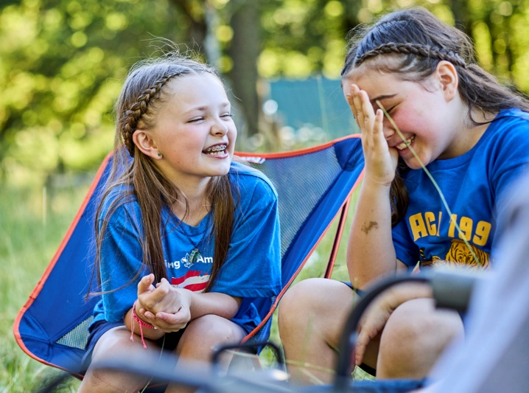
Adventure – An Adventure is a set of activities and requirements Cub Scouts complete to learn skills, try new things, and have fun. Adventures are the core of the Cub Scout program and are how Cub Scouts earn their rank.
Bobcat – The first Adventure earned by every Cub Scout earns.
Committee – A group of adults who support the Pack behind the scenes. They handle planning, finances, registration, and logistics so Den Leaders and the Cubmaster can focus on working with the Cub Scouts.
Council – The larger Scouting organization that supports Packs and Troops in a region and supports multiple Districts. It provides camps, events, training, and resources that help local Scouting units succeed. Our Council is called the Greater Colorado Council or simply referred to as Scouting Colorado.
Cubmaster – The main leader of the Pack. They run Pack meetings, support Den Leaders, and help create a fun, welcoming experience for all Cub Scouts and families.
Den – A small group of Cub Scouts who are in the same grade (or rank). Dens meet regularly to work on Adventures together and are the core of a Cub Scout’s experience.
Den Leader – An adult volunteer who plans and leads Den meetings. They guide Cub Scouts through Adventures and help them progress through the program.
District – A local group of Packs and Troops in nearby communities. It offers hands-on support, local events, and training for leaders and families.
District Executive – A professional Scouting staff member who supports Packs, Troops, and volunteers in a local area. They help provide the Packs and Troops with resources, answers to their questions, training, and community connections.
Pack – The full Cub Scout unit made up of multiple Dens, led by the Cubmaster and supported by the Committee. Pack meetings and events bring all Cub Scouts and families together.
Rank – The level a Cub Scout earns by completing Adventures for their grade. Each grade has its own rank, and Cub Scouts earn a new Rank each year.
MONTH 1: ____________________ (Theme of “Welcome & Scout Foundations”)
MONTH 1: ___________________ (Theme of “Welcome & Scout Foundations”)
Adventures Earned: Bobcat (required), electives with games and activities
Adventures Earned: Bobcat (required), electives with games and activities

- Pack Meeting: Welcome to Cub Scouts! (pages 8-9) Date: __________
  - Icebreakers & get-to-know-you games
  - What Cub Scouts is
  - Introduce Scout Oath & Law

- Den Meeting: Bobcat Adventures (page #10) Date: __________
  - Lion: “Bobcat”
  - Tiger: “Bobcat”
  - Wolf: “Bobcat”
  - Bear: “Bobcat”
  - Webelos: “Bobcat”
  - Arrow of Light: “Bobcat”

- Den Meeting: Fun and Games Adventures (page #11) Date: __________
  - Lion: “On Your Mark”
  - Tiger: “Tiger-Iffic!”
  - Wolf: “Paws of Skill”
  - Bear: “Marble Madness”
  - Webelos: “Yo-Yo”
  - Arrow of Light: “High Tech Outdoors”

- Pack Meeting: Bobcat Celebration & Recognition (page #12-13) Date: __________
  - Opening ceremony
  - Bobcat recognition (immediate or “you’ve earned it!”)
  - Fun Pack-wide game or craft
  - Introduce next month’s theme

- Monthly Committee Meeting: Date: __________
  - Confirm leadership, meeting logistics, and registration status
  - Review the starter calendar and immediate next steps

MONTH 2: ____________________ (Theme of Citizenship and Character)
MONTH 2: ____________________ (Theme of Citizenship and Character)
Adventures Earned: Citizenship (required), character building electives
Adventures Earned: Citizenship (required), character building electives

- Pack Meeting: Citizenship and Community Kickoff (page #14-15) Date: __________
  - Flag Etiquette and Respect
  - Community Helpers
  - Service Planning table

- Den Meeting: Citizenship Adventures (page #16) Date: __________
  - Lion: “King of the Jungle”
  - Tiger: “Team Tiger”
  - Wolf: “Council Fire”
  - Bear: “Paws for Action”
  - Webelos: “My Community”
  - Arrow of Light: “Citizenship”

- Den Meeting: Character Building Adventures (page #17) Date: __________
  - Lion: “Pick My Path”
  - Tiger: “Good Knights”
  - Wolf: “Cubs Who Care”
  - Bear: “Critter Care”
  - Webelos: “Aware and Care”
  - Arrow of Light: “Into the Wild”

- Pack Meeting: Our Place in the Community (page #18-19) Date: __________
  - Opening ceremony led by Scouts
  - Each Den shares what they learned
  - Each Den presents a drawing, project plan, or story from their citizenship meeting
  - Pack game or activity
  - Present a Pack service project for the following month

- Monthly Committee Meeting Date: __________
  - Check in on how meetings are going and share responsibilities
  - Plan upcoming Pack activities and support Den Leaders
MONTH 3: ____________________ (Theme of Science and Engineering)
MONTH 3: ___________________ (Theme of Science and Engineering)
Adventures Earned: Engineering electives, earth science electives
Adventures Earned: Engineering electives, earth science electives

- Pack Meeting: Engineers & Explorers Night! (page #20-21) Date: __________
  - Opening ceremony led by Scouts
  - Pack Activity: Float, Build, Test
  - Hype up the big event at the end of the month: the Raingutter Regatta!

- Den Meeting: Engineering Adventures (page #22) Date: __________
  - Lion: “Build It Up, Knock It Down”
  - Tiger: “Designed by Tiger”
  - Wolf: “Air of the Wolf”
  - Bear: “Baloo the Builder”
  - Webelos: “Build It”
  - Arrow of Light: “Engineer”

- Den Meeting: Earth Science Adventures (page #23) Date: __________
  - Lion: “Ready, Set, Grow”
  - Tiger: “Sky is the Limit”
  - Wolf: “Digging in the Past”
  - Bear: “Super Science”
  - Webelos: Earth Rocks!”
  - Arrow of Light: “Into the Woods”

- Pack Meeting: Raingutter Regatta (page #26-27) Date: __________
  - Opening ceremony led by Scouts
  - Month-in-review
  - Raingutter Regatta Pack celebration

- Monthly Committee Meeting Date: __________
  - Review what worked and plan for the next few months
  - Confirm leadership coverage and upcoming Pack events

Month 1, Week 1, Pack Meeting: Welcome to Cub Scouts!
Date: ___________________
Pre-Meeting
- As families arrive, greet everyone personally. Name tags for Scouts and adults recommended. Simple activity stations for families who arrive early – coloring sheets, LEGOs, etc.
Prep Time: 15 minutes
Materials: name tags, writing utensils, coloring sheets, printed list for game #2, printed calendars
Who leads this: Cubmaster
Opening
- Have everyone stand in a large circle
- Cubmaster: “Welcome to Cub Scouts! We are so glad you are here. Tonight is about having fun, meeting new friends, and learning what Cub Scouts is all about.”
- Introduce yourself and any other leaders, and briefly explain the night “We’ll play games, learn a little bit about Scouts, and get excited for what’s ahead.”

Get To Know You Game #1
- Name and Motion
  - Everyone stands in a circle
  - One at a time:
    - “My name is ______ and I like to ______”
    - Everyone repeats the name and motion
  - Tips: Leaders go first, keep it fast and silly, and all ages can participate.
What is Cub Scouts?
- “Cub Scouts is about having fun, learning new things, helping others, and doing our best. We camp, play games, learn skills, and try new things together. Kids learn by doing – and parents are part of the adventure too.”
- Key points: family centered program, organized by age (Dens), parents lead the program (and more volunteers makes the Pack stronger!), and that everyone does their best – no one has to be perfect.
Get to Know You Game #2
- Find Someone Who… (Scout Edition)
  - Give each Scout a simple list:
Scout Oath:
On my honor, I will do my best to do my duty to God and my country and to obey the Scout Law; to help other people at all times; to keep myself physically strong, mentally awake, and morally straight.
    - Has been camping
    - Likes to hike
    - Is excited to try Cub Scouts
    - Wants to learn how to fish
    - Likes animals
  - Scouts mingle and find someone who matches each one Give each Scout a simple list:
Introducing Scout Oath & Law
- “The Scout Law has 12 points. Each is a goal for every Scout. A Scout tries to live up to the Law every day. It is not always easy to do, but a Scout always tries”
Scout Law:
A Scout is trustworthy, loyal, helpful, friendly, courteous, kind, obedient, cheerful, thrifty, brave, clean, and reverent
- Explain what the different points of the Scout Law mean
  - Scout Law Charades
    - Choose 4-6 points of the Scout Law. Leaders or Scouts act them out. Audience guesses. After each one, ask “What does that look like in real life?”
    - End with “We don’t have to be perfect – we just have to try our best.”
Expectation Setting
- For Scouts: Be kind, listen when others talk, have fun and try your best, etc.
- For Parents: The Pack is successful when families help, you don’t have to know everything, and we’ll learn together. This is also a great time to pass out the calendar for the next 3 months.
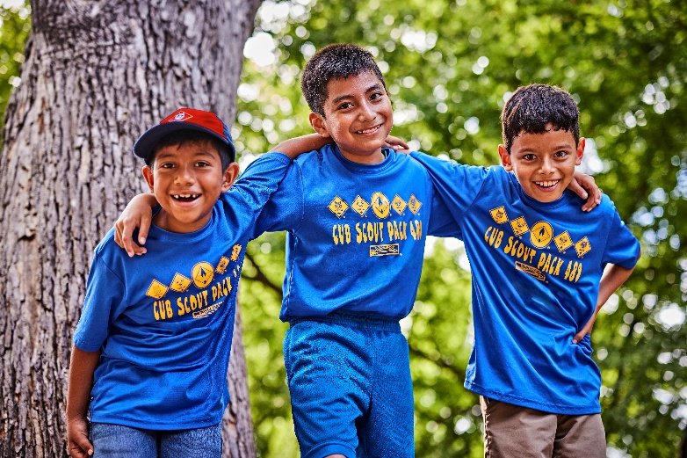
Big Pack Game – Scout Law Freeze Tag
- One or two players are “it.” If tagged, freeze. To unfreeze: name a point of the Scout Law OR say one way to be kind or helpful
Closing / Reflection
- Teach the Scout sign
- Preview what’s next
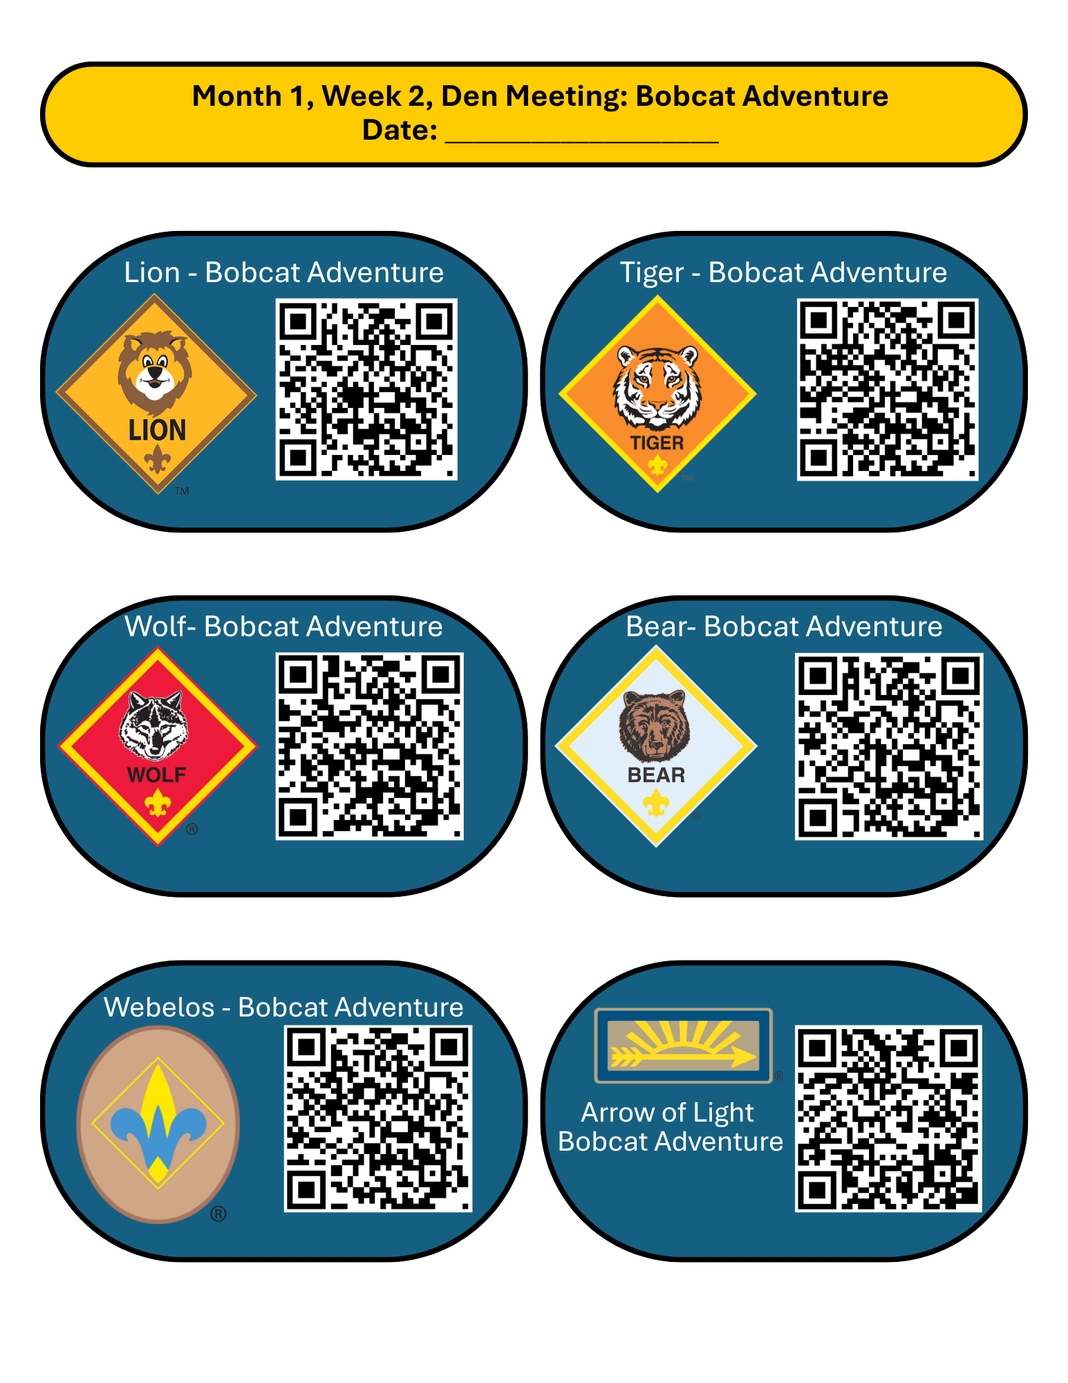
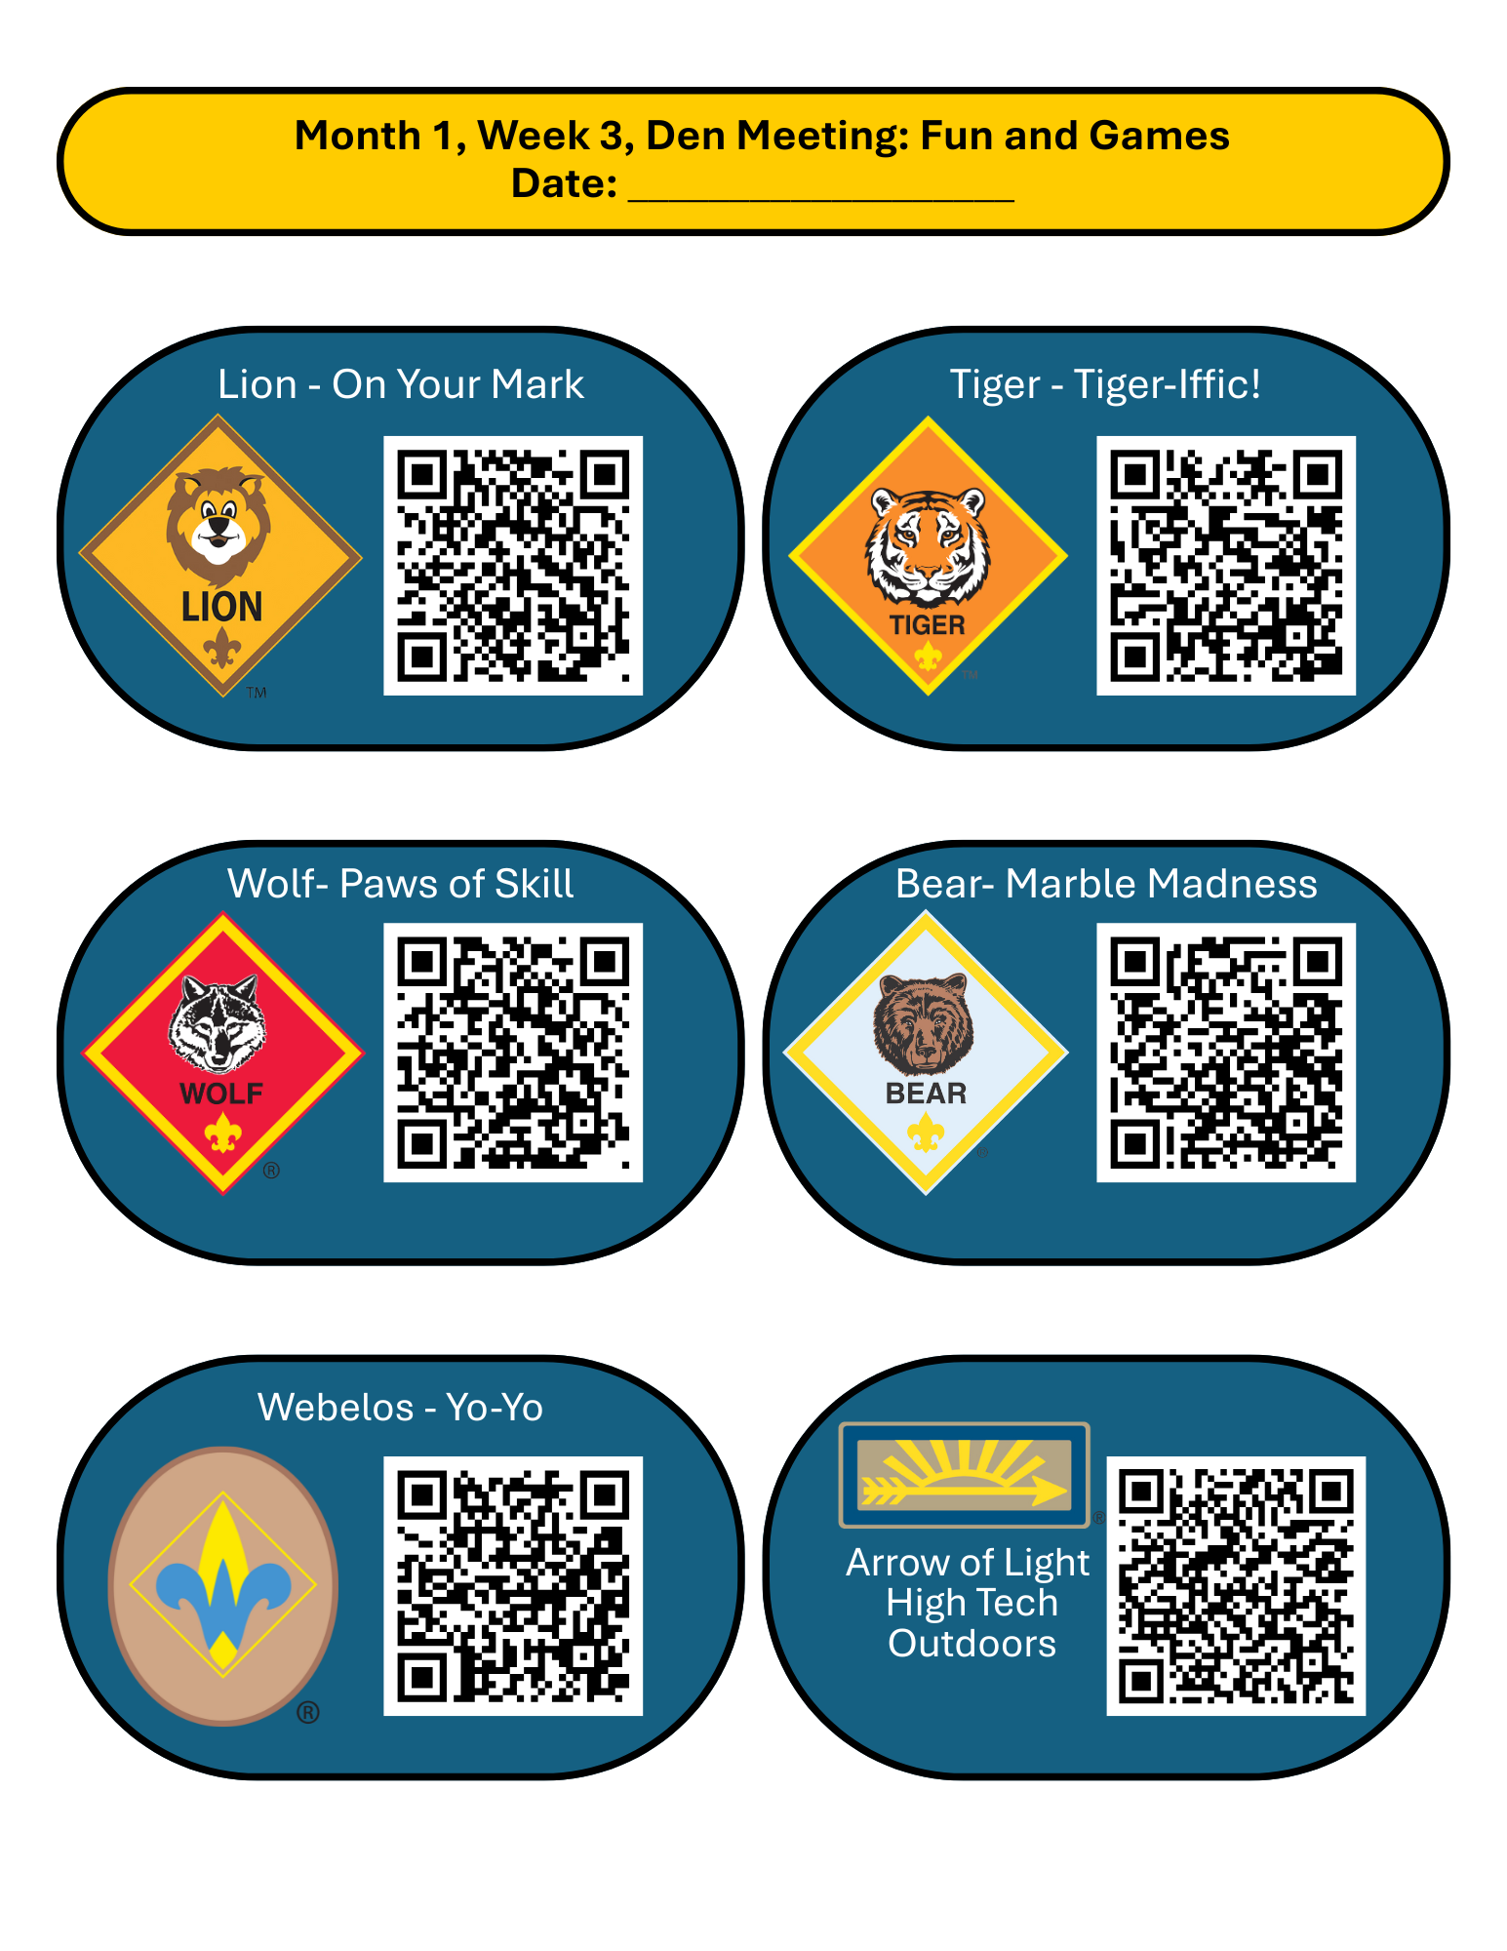
Month 1, Week 4, Pack Meeting: Bobcat Celebration and Recognition!
Date: ___________________
Pre-Meeting
- As families arrive, greet everyone personally. Coloring sheets or other simple activities for early arriving families.
Prep Time: 30 minutes
Materials: American flag, Adventure pins/ cards/ beltloops
Who leads this: Cubmaster with help from Den Leaders
Opening & Flag Ceremony
- Call the Pack to attention
- Present the colors
- Recite the Pledge of Allegiance
Welcome & Setting the Tone
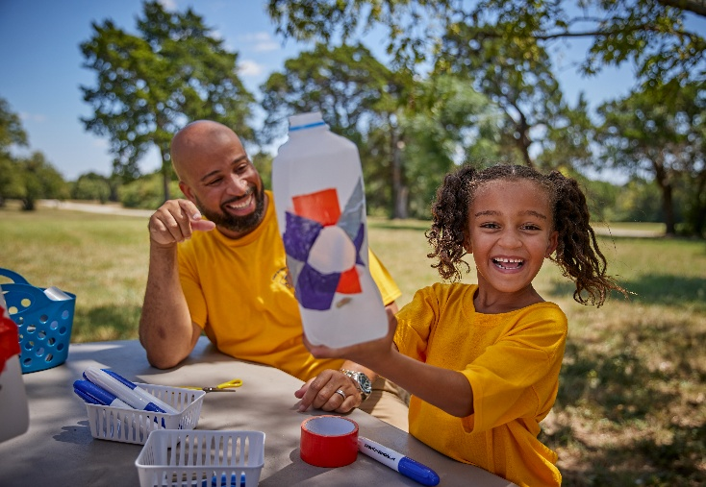
- “Welcome to our Bobcat Celebration! Over the past few weeks, our Scouts have learned what it means to be a Cub Scout – our values, our promises, and how we treat others. Tonight, we get to celebrate their very first achievement!”
- Briefly explain:
  - Bobcat is earned by every Cub Scout
  - It represents learning the foundations of Scouting
  - This is a big deal – especially for brand-new Scouts
Scout Oath and Law Review
- Whole Pack Activity
  - Recite the Scout Oath and Law together
  - Ask 3-4 Scouts (or Dens) to share:
    - One part of the Law they remember
    - What “Do Your Best” means to them
Adventures Recognition Ceremony
- Call each Den up individually
- Den Leader shares their experience with their respective Bobcat adventure and their elective from week 3
- Cubmaster presents pins/beltloops/recognition cards
  - Optional: parents help pin the badge on their Scout
- “The Bobcat adventure teaches us who we are as Scouts. Adventures with fun and games teach us how we work together. Every meeting builds on the last, and this is just the beginning of your Scouting journey.”
What Comes Next
- Overview:
  - Scouts will work on adventures by Den
  - Many adventures can be finished at home with family
  - Families will continue to help make this Pack their own
- Mention:
  - Next Pack meeting theme
  - Any upcoming activities or events
Big Pack Game
- Choose something cooperative and energetic, such as:
  - Scout Law Relay
  - Sharks & Minnows (Scout-themed)
  - Human Knot
  - Freeze tag with Scout Law words
Closing / Reflection
- Thank families for being part of the Pack

- Optional Scoutmaster reflection on kindness or helping others

Month 2, Week 1, Pack Meeting: Citizen and Community Kickoff!
Date: ___________________
Pre-Meeting
- As families arrive, set up a table with paper, markers/crayons, and stickers. Give kids the prompt of “draw someone in your community who helps others.”
Prep Time: 45 minutes
Materials: Craft materials and paper, American flags, supplies for game
Who leads this: Cubmaster with help from Den Leaders
Opening & Flag Ceremony
- Call the Pack to attention, present the colors
- Recite the Pledge of Allegiance
- Brief teaching moment:
  - “When we stand for the flag, we’re showing respect for our country and for each other.”
Welcome & Theme Introduction
- Cubmaster: “This month, we’re going to learn about citizenship and community – what it means to be part of something bigger than ourselves. Being a good citizen doesn’t mean you have to be grown up. Cub Scouts learn how to help, respect others, and make their community better right now.”
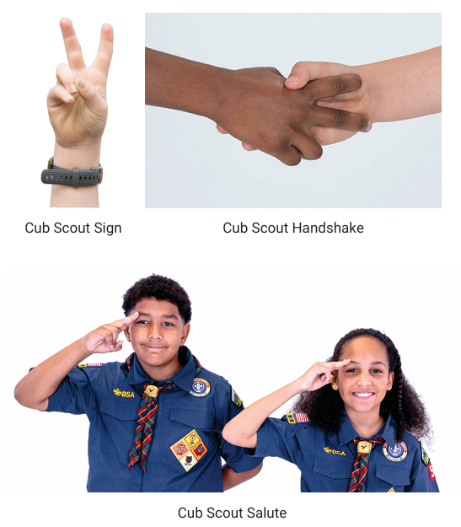
Flag Etiquette and Respect
- Cover:
  - How to stand respectfully
  - Scout salute vs Scout sign
  - Why we treat the flag with care
  - How to do a traditional flag ceremony
- Make it interactive:
  - Ask Scouts to demonstrate the salute
  - Practice folding the flag
  - Practice a flag ceremony
- Leaders: Choose a Den Order for the next few meetings on which Den holds the flag ceremony
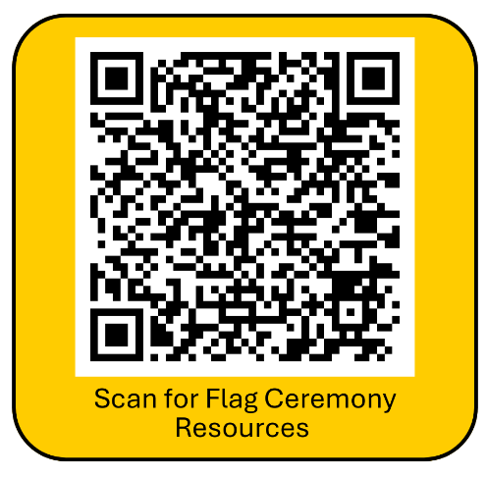
Community Helpers Activity
- Whole Pack Game: “Why Helps Our Community?”
  - Call out a scenario (“Someone is hurt,” “There’s a fire,” “You need a book,”
  - Scouts shout or point to who helps
  - Optional: have Scouts move to labeled corners of the room
- “Citizens help others – and so do Scouts!”
Service Planning Table
- Set up one or two tables with poster paper, markers, sticky notes, etc.
- Prompt families with simple questions:
  - Who needs help in our community?
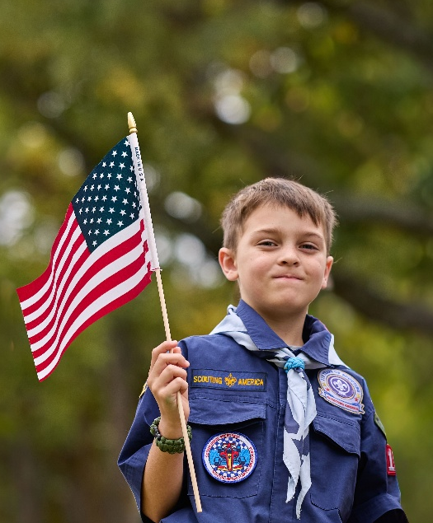
  - What are ways kids can help?
  - What would be fun and helpful?
- Examples:
  - Park clean-up, food drive, thank you cards, helping another Pack or Troop, etc.
Pack Game
- Suggested game options:
  - Cooperative relay (carry supplies together)
  - Build-a-town challenge with cups or blocks
  - Scout Law tag (citizenship-focused words)
- Key rule: The game should require teamwork, not competition.
What’s Coming Next
- Dens will work on citizenship requirements
- Scouts will explore how they care for others
- A Pack service project will be chosen soon
Closing / Reflection
- Simple reflection: “One way I can be a good citizen this week is…”
  - Have Scouts raise hands to answer
- Close with Scout sign
- Thank families and announce any upcoming events or reminders
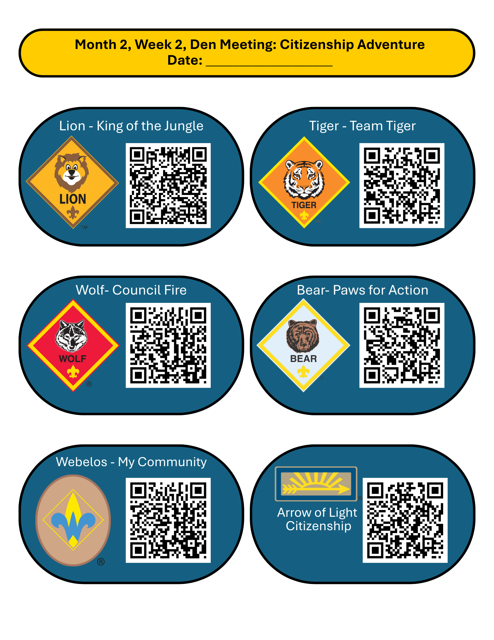
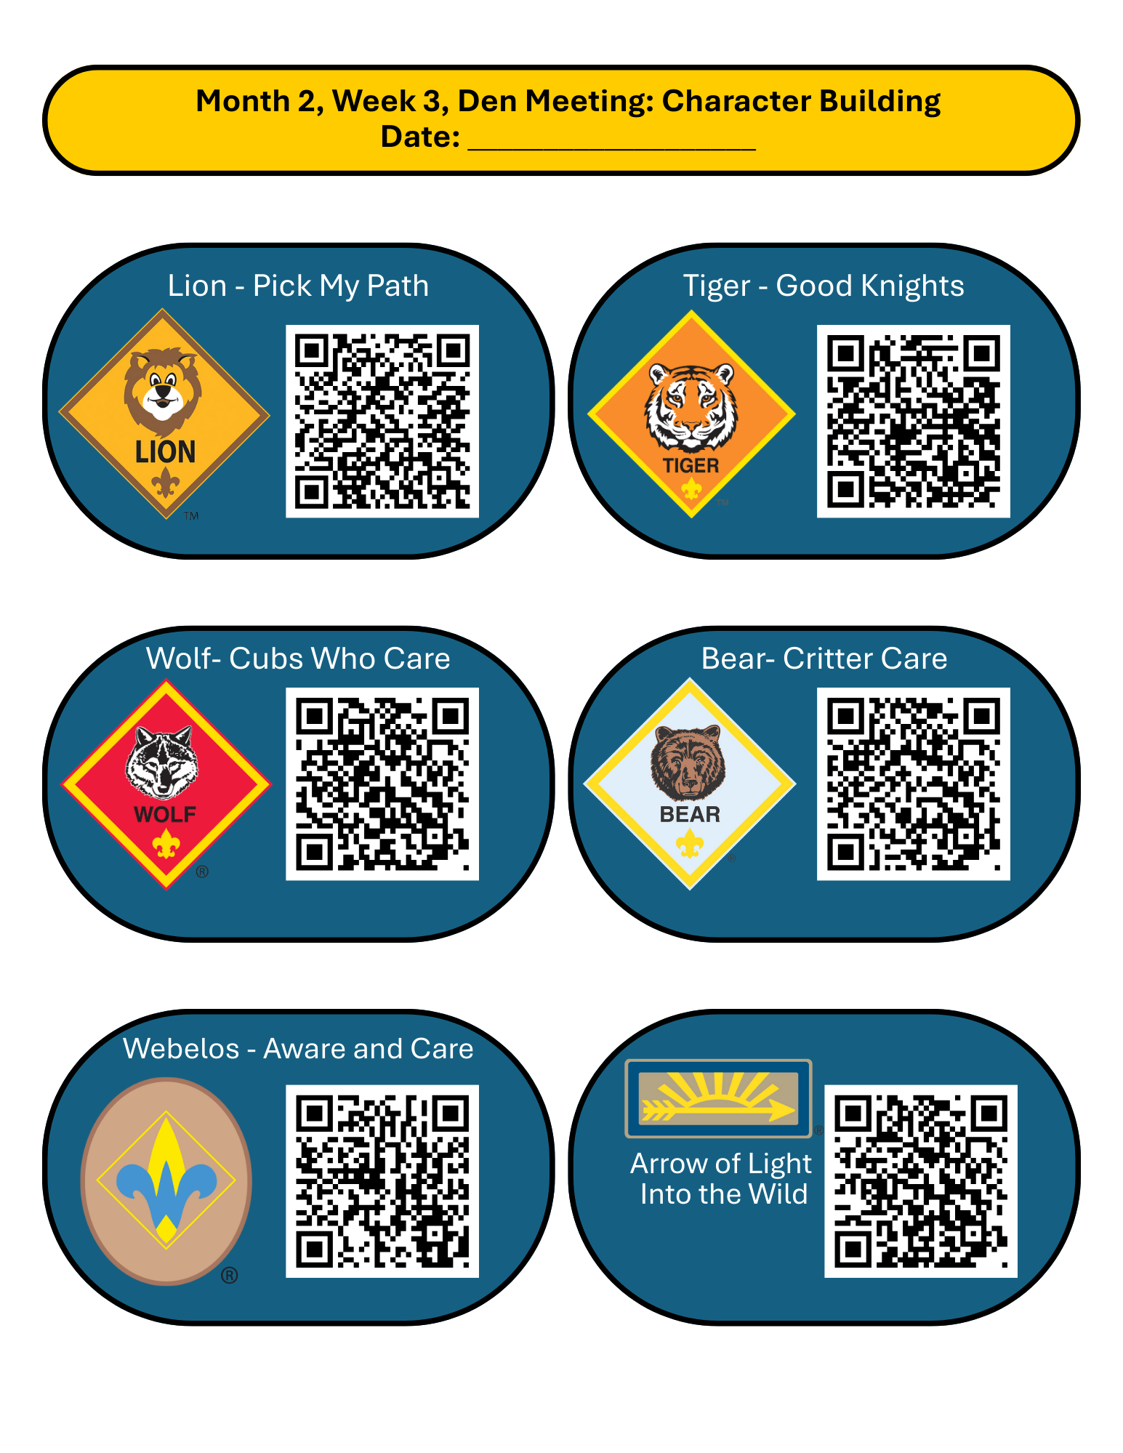
Month 2, Week 4, Pack Meeting: “Our Place in the Community”
Date: ___________________
Pre-Meeting
- As families arrive, greet everyone personally. Coloring sheets or other simple activities for early arriving families.
Prep Time: 30 minutes
Materials: Materials for chosen game, large poster, craft supplies
Who leads this: Cubmaster with help from Den Leaders
Opening & Flag Ceremony
- Have one pre-chosen Den do the flag ceremony
- Recite the Pledge of Allegiance
  - “When we show respect, we show we care about our community.”
Cubmaster Minute
- Welcome and any announcements
- “This month, every Den learned what it means to be a good citizen – not just in our country, but in our homes, our schools, and our neighborhoods.”
Den Presentations
- All Dens have a chance to present what they learned while completing the Citizenship Adventure and/or their respective character elective adventure
- Recognize the earning of Adventures
  - Can either be verbally or with the physical award. Praise effort and participation. Even if awards come later, say “you’ve earned it!”
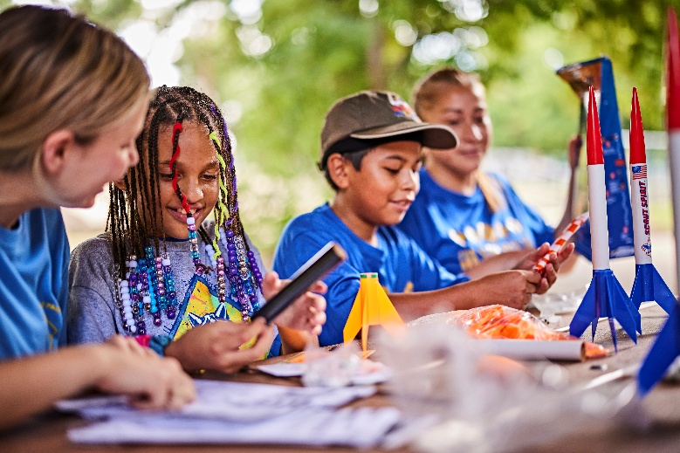
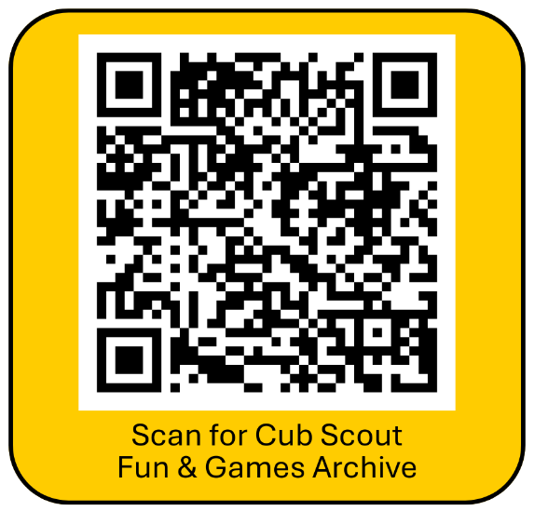
Pack Group Game or Activity

Group Reflection
- Gather everyone together and ask “What did you learn about being a good citizen? About being a good person? How can kids make a difference?”
- Have 1 Scout per Den answer
- “Citizenship isn’t about age – it’s about choices.”
Service Project Announcement
- Introduce a simple Pack service project for the following month
  - Examples: park clean-up, food drive, thank you cards for community helpers, project for your chartering organization, etc.
  - Explain how this is the next step of everything they’ve learned
  - Ask for parent volunteers and commitment to help with the service project
Community Impact Activity
- Pack Activity: “We Belong Here”
  - Set up a large poster or banner titled ‘Our Place in the Community’
  - With markers and sticky notes, prompt Scouts to add:
    - One way Cub Scouts help others
    - One place in the community they belong
  - Cubmaster: “Everything on this poster shows how Cub Scouts help make our community stronger. These are things kids can do right now – and you are already doing them.”
Closing / Reflection
  - End with any reminders of upcoming events
  - “This month we learned that being a Scout means being kind, helpful, and caring – at home, in our community, and in the world.”


Month 3, Week 1, Pack Meeting: “Engineers & Explorers Night!”
Date: ___________________
Pre-Meeting
- As families arrive, greet everyone personally.
Prep Time: 1 hour
Materials: Shallow tubs with water, aluminum foil, pennies or small weights, towels, straws, other craft materials
Who leads this: Cubmaster with help from Den Leaders
- Set out bins of aluminum foil, craft sticks, plastic cubs, straws, tape, etc.
- Prompt early arriving Scouts “Can you build something that floats?” No further instructions. Let Scouts experiment.
Opening & Flag Ceremony
- Have one pre-chosen Den do the flag ceremony
- Recite the Pledge of Allegiance
Welcome & Theme Introduction
- Cubmaster: “Tonight we are engineers and explorers. Engineers design and build things. Explorers try new ideas and learn from what works and what doesn’t. This month, we’re going to build, test, and improve – just like real engineers!”
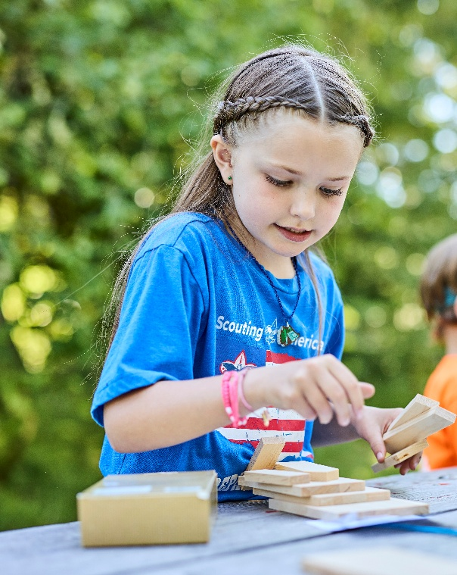
Mini-Demo: Float, Build, Test
- Show a simple example:
  - A foil boat
  - Drop it in water
  - Add pennies or small weights
- Ask:
  - Why did it float
  - What made it sink?
- Tip: Keep it fun – curiosity over correctness
Main Activity: Float, Build, Test (20-25 minutes)
- Materials needed:
  - Shallow tubs or gutters with water
  - Aluminum foil
  - Pennies, washers, small weights
  - Other craft materials (straws, tape, popsicle sticks, etc.)
  - Towels
- How it works:
  - Scouts work in Dens or small groups
  - Build a floating design
  - Test it by adding weights
  - Improve and test again
- Leader role:
  - Ask questions, encourage trying again, celebrate effort
- Key Message: “Engineers learn by testing and improving”
Explorer Reflection
- Ask:
  - What worked? What didn’t? What would you change next time?
- Accept all answers – this is about thinking, not winning.
Build-a-Bridge Activity or other Pack Game
- Materials needed:
  - Paper
  - Tape
  - Small object – ball, stuffed animal, water bottle, etc.
  - Chairs or tables
- How it works:
  - Scouts work in Dens or small groups
  - Teams build a bridge using tape between two chairs. The bridge must hold a small object.
What Comes Next
- Dens will work on building and designing related adventures
- Talk and build excitement about the upcoming Raingutter Regatta boat race!
Closing / Reflection
- End with any reminders of upcoming events
- “Engineers and explorers don’t always get it right the first time – but they keep trying. That’s part of being brave, thrifty, and trustworthy!”

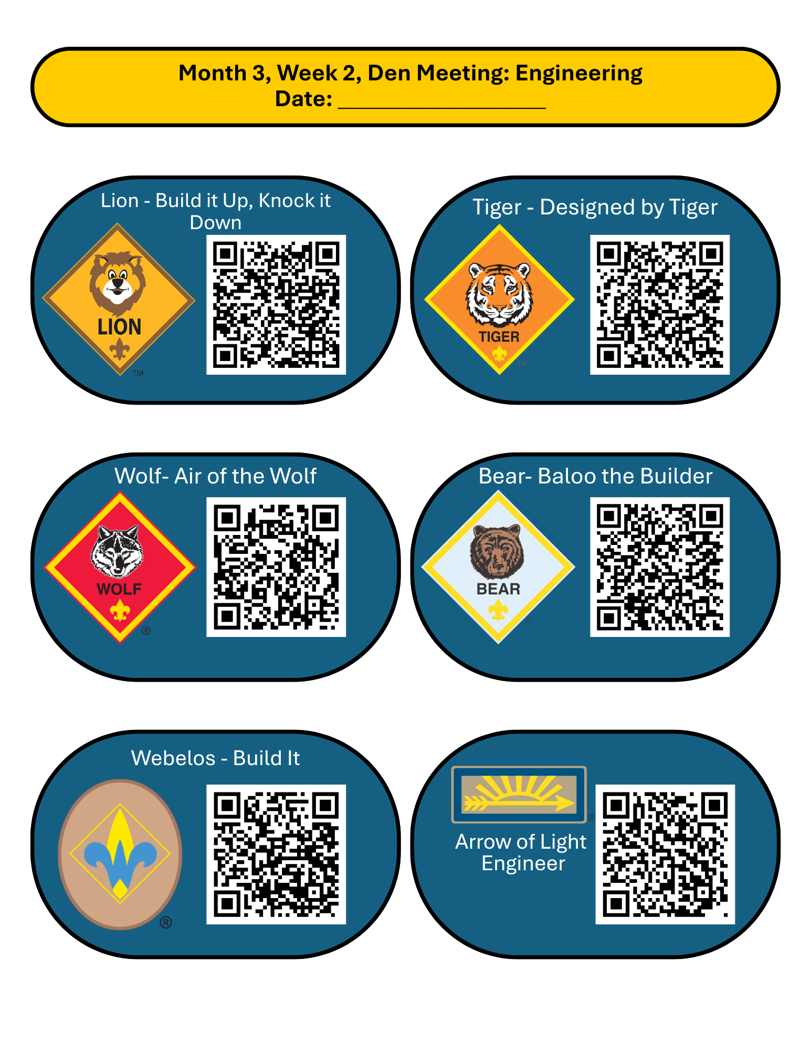
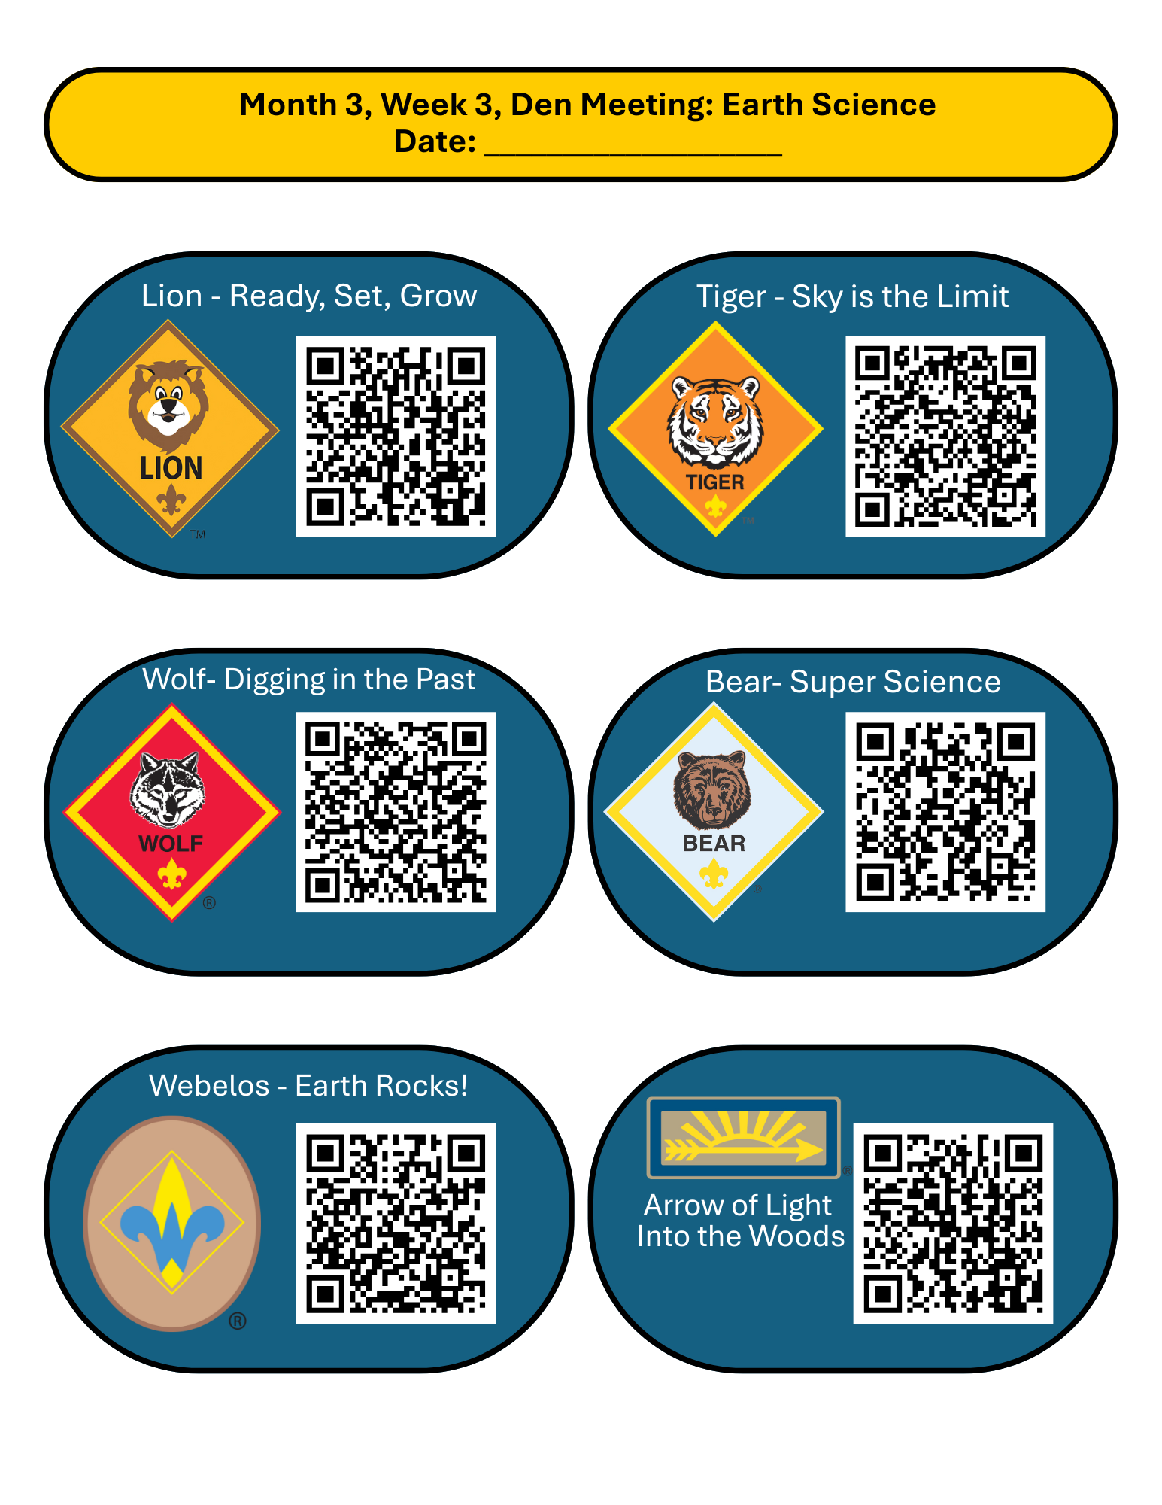
Raingutter Regatta Checklist
The Raingutter Regatta is one of Cub Scouting’s most exciting and memorable Pack events – and because it’s a hands-on, water-based activity, it requires a bit more preparation than a typical Pack meeting. Having materials ready, roles assigned, and the space set up ahead of time allows the focus to stay on fun, creativity, and cheering Scouts on.
Before the Meeting
- 1-2 weeks before
  - Confirm meeting location & water access
  - Choose boat type (official Scouting America kits OR foam boats)
  - Recruit helpers (aim for 4-6 adults)
  - Decide how many race lanes you’ll run
- 3-5 days before
  - Gather all materials
  - Pre-cut boats or foam shapes
  - Test gutters with water

  - Prepare recognition categories
Materials to Bring
- Race Setup
  - Official Scouting America Raingutter tracks OR actual raingutters
  - Tables or stands
  - Buckets / tubs (water in + water out)
  - Towels (more than you think)
  - Straws (1 per Scout + extras)
- Boat Build Station
  - Boat kits, foam boats, or pool noodle boats (1 per Scout)
  - Markers
  - Stickers
  - Masking tape
  - Toothpicks
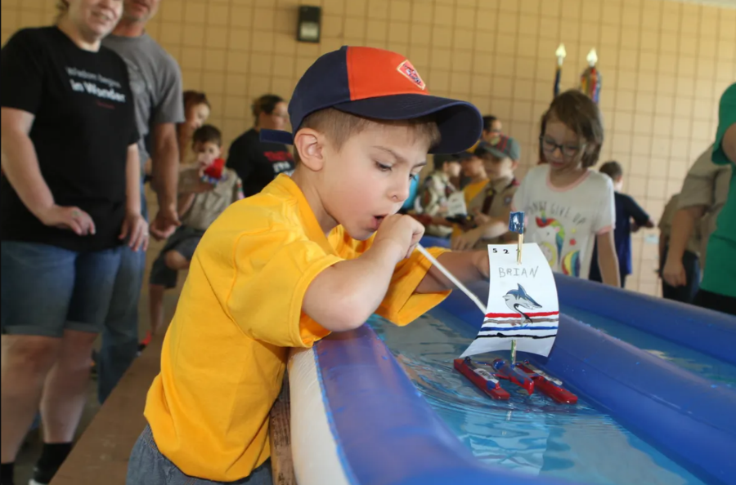
  - Name labels or Sharpies
Set Up (Arrive Early)
- Set up gutters and tables
- Fill water buckets
- Lay out build supplies
- Assign volunteers to stations
- Place towels near race area
Assign Roles
- Race Starter: “Ready, Set, Blow!”
- Lane Helpers (1 per lane)
- Build Station Helper
- Scorekeeper
During the Event

- Keep the rules simple: blow only
- Rotate Scouts quickly
- Allow multiple races for younger Scouts
- Focus on fun, not perfection
Recognition (Everyone gets one)
- Best Design
- Most Creative
- Best Teamwork
- Engineer-in-Training
- Did Their Best
After the Meeting
- Drain gutters
- Wipe tables / floors
- Thank volunteers
- Store materials for next year
Month 3, Week 4, Pack Meeting: “Raingutter Regatta!”
Date: ___________________
Pre-Meeting
- Have sample boats on display
Prep Time: 1 hour
Materials: All materials needed for a Raingutter Regatta, photo presentation (optional)
Who leads this: Cubmaster with help from Den Leaders
- Play upbeat music
- Volunteers help Scouts check in and get name tags
Opening & Flag Ceremony
- Have one pre-chosen Den do the flag ceremony
- Recite the Pledge of Allegiance
Overview of Events
- “Scouts and families – tonight is a special night. All month long, we’ve been learning how to think like engineers and explorers – trying ideas, testing them, and learning from what happens. Tonight, we get to put that all into action with one of the most exciting Cub Scout events there is: the Raingutter Regatta!”
- “Here’s how tonight will work. First, we’re going to spend a little time remembering what we’ve learned this month. Then, each Scout will design and decorate one boat right here tonight. Once the boats are ready, we’ll head to the race lanes. Scouts will race by blowing their boats across the water using straws – no hands, just teamwork, cheering, and lots of fun.”
- “This isn’t about having the fastest boat. It’s about trying something new, encouraging each other, and doing your best. If your boat goes sideways, that’s okay. If it sinks, that’s okay. If water splashes, that’s okay too.”
- “The most important thing is that we have fun together as a Pack. Let’s get ready to engineer, explore, and race!”
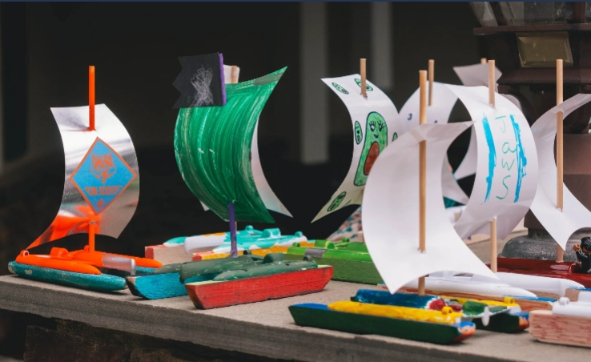
Month-in-Review: Engineers and Explorers
- Quick Den Shout-Outs
  - Lions – trying new things and working together
  - Tigers – building and improving designs
  - Wolves – caring for others and the world around them
  - Bears – learning responsibility and creativity
  - Webelos – awareness, planning, and teamwork
  - AOL’s – leadership and problem solving
- Ask:
  - “What did we build or design this month?”
  - “What worked the first time? What didn’t?”
  - What did we learn about trying again?”
Boat Build & Prep Time (20-25 minutes)
- “You’ll design one boat tonight. It doesn’t need to be perfect – it just needs to float”
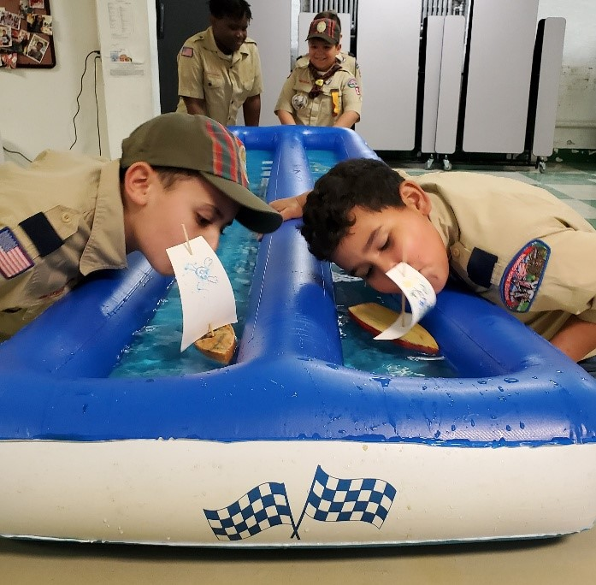
- How it runs:
  - Scouts work at tables by Den
  - Adults assist but do not take over
  - Encourage creativity and teamwork
- Reminders:
  - Keep boats simple
  - Write Scout names on boats
  - No fixing boats after racing starts
The Raingutter Regatta Races
- Depending on how races / heats were decided, call Dens / racers up
- Cheer for all racers
- Keep rules simple: blow through straws only and no touching boats during races
- Refer to the checklist and online resources for more specific information
Recognition and Celebration
- Celebrate all participants
- Award winners in their specific categories
Closing / Reflection
- End with any reminders of upcoming events
- Ask for extra hands for cleanup if necessary
- Give a brief preview of future Pack adventures
- Reinforce that Cub Scouts builds confidence over time
What to Do After Month 3
Congratulations! Your Pack has completed the first three months of the Cub Scout program! Now is the perfect time to pause, reflect, and set the stage for continued success. Take a few moments to celebrate what the Scouts have accomplished so far. Recognize the achievements of each Den, whether that’s completing Bobcat requirements, exploring citizenship and character-building adventures, or designing and racing boats in the Raingutter Regatta. Highlighting these successes reinforces confidence and keeps both Scouts and families motivated.

This is the moment where your Pack transitions from a guided startup to leader-driven success.

STEP 1: Pause and Reflect
Before planning what’s next, take 10-15 minutes at your next committee meeting to ask:
- What went really well in the last three months?
- What felt hard or stressful?
- What activities did Scouts talk about the most?
- What did parents seem excited to help with?
STEP 2: Build the next 3-6 months of the Pack calendar
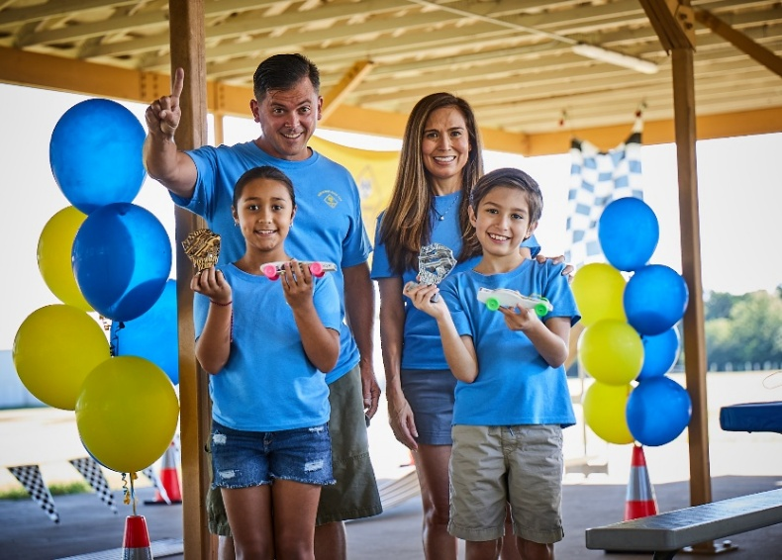
If you haven’t done so already, it’s time to plan what’s next! Feel free to use the same structure you’ve already been using (Pack -> Den -> Den -> Pack) or adjust as needed.
Strong themes to consider:
- Outdoors & Camping
- Service & Community
- Sports & Games
- Family Traditions
- Duty to God
- Pinewood Derby
You do not need to plan every detail yet – just:
- Meeting dates
- Committee meeting dates (strong Packs have committees that meet once a month!)
- Pack meeting themes
- Big events (campouts, service projects, Pinewood Derby, Blue & Gold Banquet)
STEP 3: Shift Ownership to Den Leaders
By now, Den Leaders should choose what adventures their Den completes next, prep and run Den meetings independently, and ask for help before they’re overwhelmed. As Cubmaster, your role is now to coordinate Pack meetings, keep the calendar moving, and to encourage leaders – not micromanage them. Provide them with resources, guidance, and checklists, but let them make decisions and lead their Scouts.
A good Cubmaster mantra: “I don’t need to run everything – I need to support the people who do.”
STEP 4: Keep Recognition Frequent and Visible
Kids stay in Scouting when they feel successful and recognized for what they do. Make sure you recognize achievements at every Pack meeting, celebrate effort, not just completion, and thank parents publicly for helping.
Small wins matter – especially for new families.
STEP 5: Use Your Support System
You are not doing this alone. Reach out to:

- Your District Executive
- Other Cubmasters in your District and area
- Roundtables, training events, and online resources.
FINAL REMINDER
Cub Scouts is not about perfection. It’s about showing up, trying new things, learning together, and most importantly – doing your best.
You’ve already proved in the first three months that your Pack can succeed. Trust your leaders, trust the process, and don’t be afraid to make the program your own.

